VE-DAY
What is VE-day?
VE-day or Victory in Europe day marks the end of World War Two when fighting against Nazi Germany in Europe came to an end.

On the 8th of May the Prime Minister Winston Churchill made an announcement on the radio at 3pm that the war in Europe had come to an end, following Germany's surrender the day before(the 7th of may).
Many people were extremely happy that the fighting had stopped and there were big celebrations and street parties they sang songs and had bonfires.
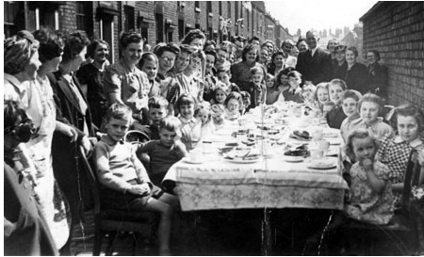
Huge crowds with lots of dressed in red, white and blue gathered outside Buckingham Palace in London, they cheered as King George VI and his family including Princess Elizabeth and Princess Margaret came out onto the balcony to greet everybody. 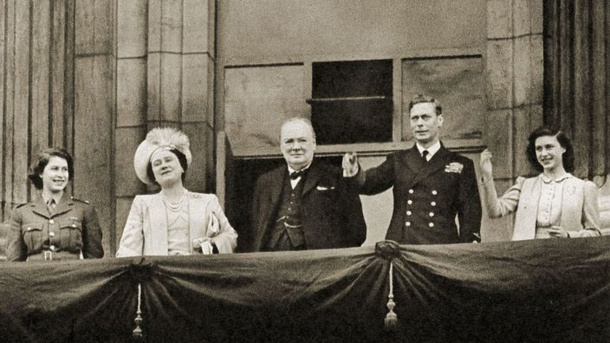 By Holly Baker

