Victoria Sponge

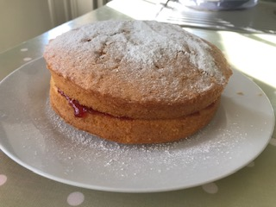

Ingredients
- 175g margarine
- 175g caster sugar
- 3 large eggs
- 175g self-raising flour
- 1 level teaspoon of baking powder
- Strawberry jam for filling
- Icing sugar

Things you will need
- x2 18cm round tins
- Mixing bowl
- Electric whisk
- Spatula

Chocolate Swiss Roll

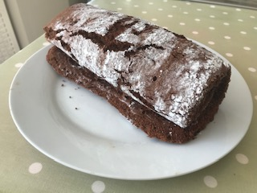

Ingredients
- 4 eggs
- 100g caster sugar
- 65g self-raising flour
- 40g cocoa powder
- Nutella for filling

Things you will need
- 33x 23cm tin
- Greaseproof paper
- Mixing bowl
- Electric whisk
- Spatula

Bread
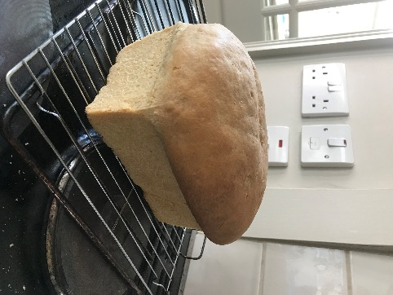
Ingredients
- 500g strong white bread flour
- Extra flour for dusting
- 10g salt
- 7g fast-action dried yeast
- 40ml olive oil, plus extra
for oiling
- 320ml cool water
Things you will need
- Bread tin
- Bowl
- Cling film
- Scales
- Greece proof paper

Fairy cakes
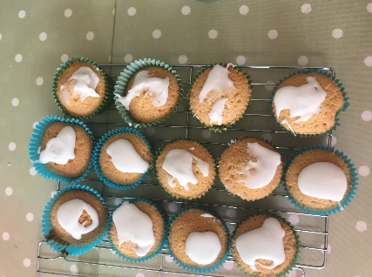
Ingredients
- 175g caster sugar
- 175g butter, softened
- 3 eggs beaten
- 175g self- raising flour
- 1 tsp baking powder
- 140g icing sugar
- 4 tsp cold water
Things you will need
- Bun tin
- Bowl
- Paper cake cases
- Electric whisk
- Spatula

Jam Tarts
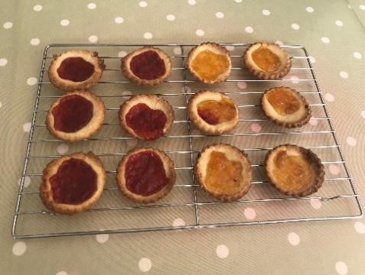
Ingredients
- 150g plain flour
- 75g margarine
- 50g icing sugar
- 1 egg
- Pinch of salt
- Jam of your choice
Things you will need
- Take marg out of fridge 45mins before starting
- Muffin tray
- Bowl
- Spatula
- Cooling rack

Flapjacks
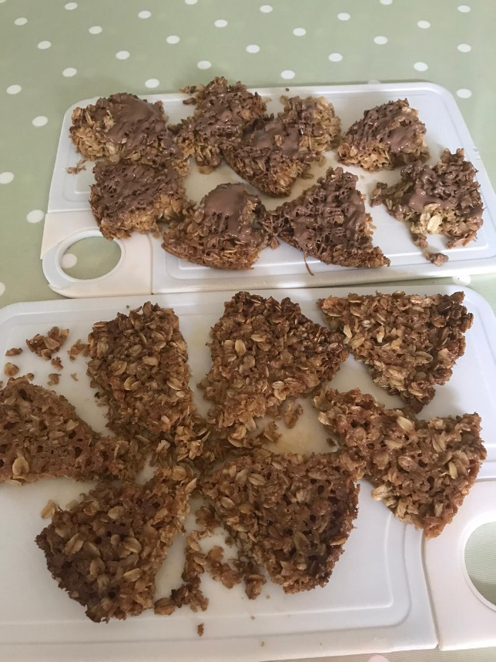
Ingredients
- 6oz butter
- 6oz demerara sugar
- 8oz oats
- Pinch salt
- Chocolate
- Water
Things you will need
- Round tins x2
- Bowl
- Metal spoon
- Foil liner
- Saucepan

Apple Pie
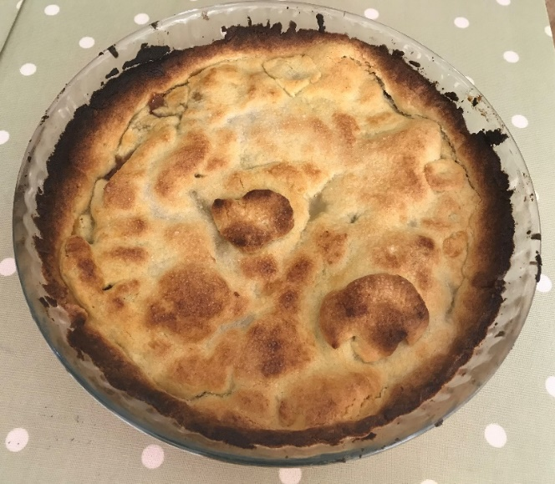
Ingredients
• 200g plain flour
• 50g ground almonds
• 140g butter chopped into pieces
• Grated rind of one orange
• 50g caster sugar
• One egg yolk
• Teaspoon of cold water
• 700g Bramley apples
• Soft brown sugar to sprinkle on top

Things you will need
• 24cm plate or dish
• Sause pan
• Cling film
• Fridge to chill pastry
• Metal spoon
• Cheese Grater
• Bowl
• Rowling pin
• Sharp knife

